Product Data Sheet

Lid warning sign 300mm 2500V 6m PY1
Reference GRC300KV256MPY1

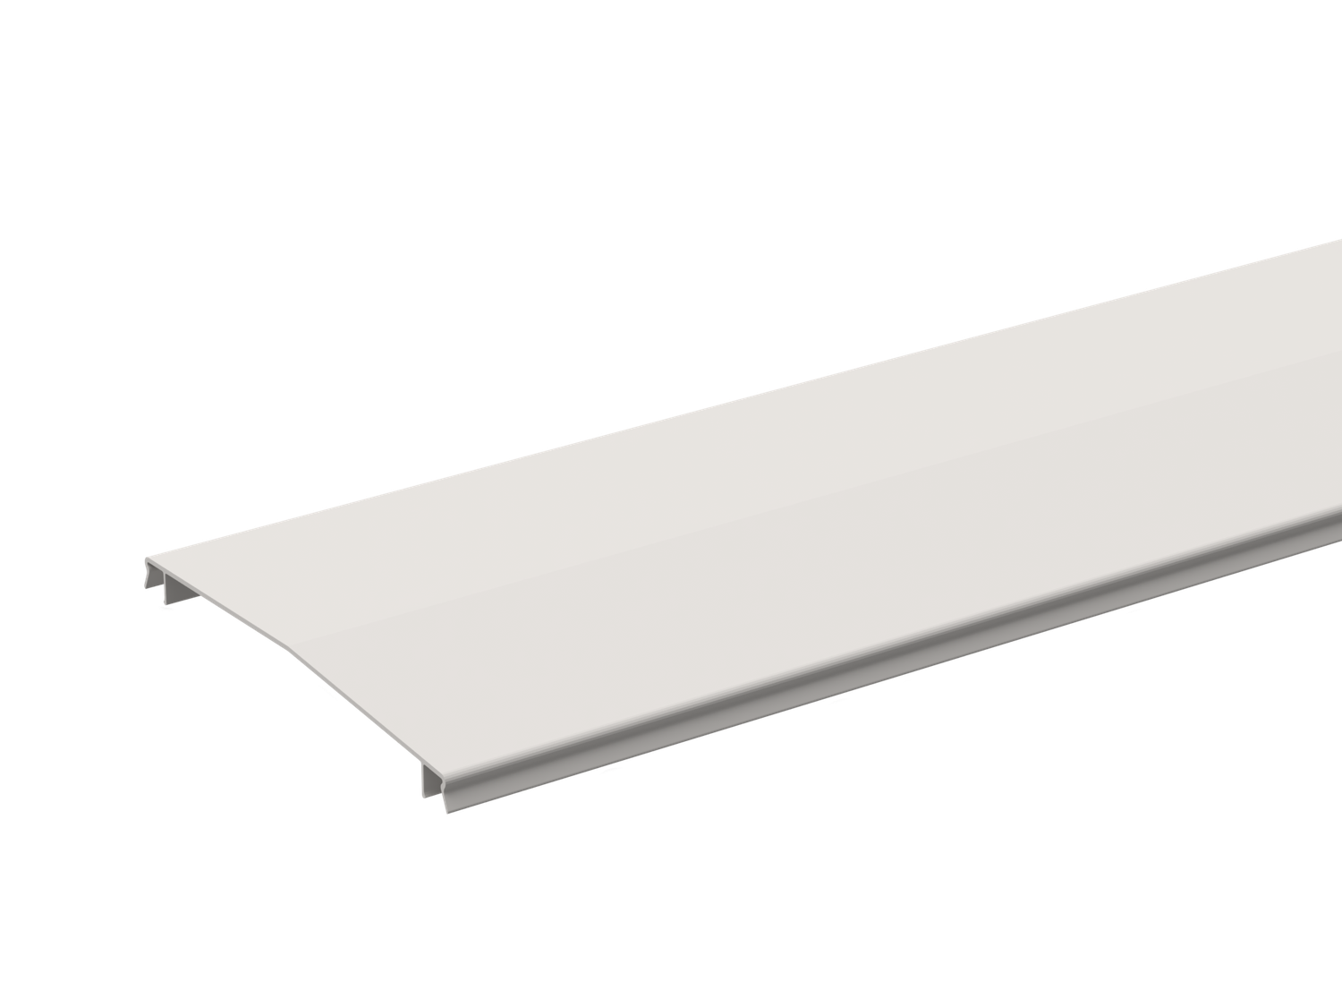

Base

Activity Product family Brand
Range

Cable support systems Cable trays
Mita Cabsys

This information is meant as an indication and cannot be used to ensure fitness with any solution. This file is subject to change, for detailed information, please contact our Customer Service.
Activity Cable support systems
Product family Cable trays
Brand Mita
Range Cabsys
GTIN 7321678010287

Commercial and Web

Short description Lid warning sign 300mm 2500V 6m PY1
Medium description Mita - Lid warning sign 300 mm 2500V - L=6 m - GRP PY1
Length 6000 mm
Width 300 mm
Material GRP
Material type or surface treatment PY1
Environmental corrosion class CX

ETIM (EC002403-Cover for cable support system)

Cover width (EF005146) * mm
Material thickness (EF000386) * mm
Suitable for cable tray (EF005166) *
Suitable for wire mesh tray (EF005163) *
Suitable for cable ladder (EF005165) *

Length (EF001438) * mm
This information is meant as an indication and cannot be used to ensure fitness with any solution. This file is subject to change, for detailed information, please contact our Customer Service.
Type of fastening (EF002442) *
Suitable for circuit integrity * (EF007806)
Material (EF002169) *
Stainless steel, pickled (EF006388) *
Material quality (EF001257) *
Surface protection (EF000139) *
Colour (EF000007) *
RAL (EF000116) *

Logistic

Pack 1 type Each
Quantity pack 1 1
Weight pack 1 13 kg
Length pack 1 6000 mm
Width pack 1 300 mm
Height pack 1 3 mm
Customs code 39169010
Net weight 13 kg
Country of origin GB

Certification

ETIM class EC002403
BS 476 - Part 7 1997 Passed
BS EN 60695-2-12 2001 Passed
UL94 V0 Passed
UL94 5VA Passed

Status product

Product status Commercialized

For the latest information check http://wibe-group.com/cable-support- systems/cable-trays/covers/lid-warning-sign-300mm-2500v-6m-py1

